Title of paper (use ‘Title’ style)
Author One¹, Author Two² and Author Three³ (initials and surnames only)
Note: Presenting author’s name should be underlined.
1.Position title, Organisation Name, City State Postcode. Email:
2.Position title, Organisation Name, City State Postcode. Email:
3.Position title, Organisation Name, City State Postcode. Email:
…etc
Keywords: list keywords here

ABSTRACT (USE ‘heading 1’ STYLE)
300 word abstract here…(Use ‘Body Text’ style)
Note: Do not use extra returns between paragraphs, or double spaces between sentences.

introduction (USE ‘heading 1’ STYLE)
Text here… (Use ‘Body Text’ style)
Figures should be placed within the body of the paper soon after being mentioned.
Crop images to best reflect subject matter.
Insert image using ‘Image style’
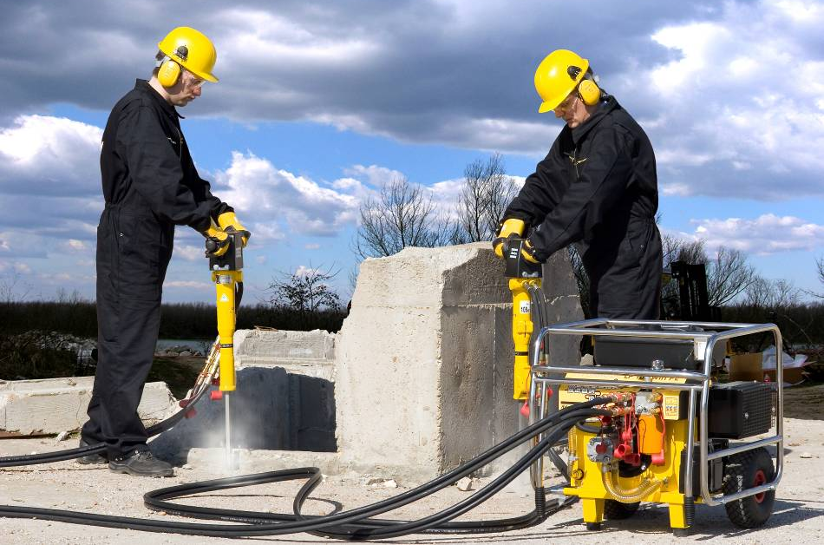
FIG 1 – Caption …
Tables should be placed within the body of the paper soon after being mentioned.
TABLE 1 – Caption …
Column 1 (Use ‘Table text header row’ style) | Column 2 | Column 3
X (Use ‘Table text’ style’) | 10 | 50
Y | 20 | 55
Z | 30 | 62
X | 40 | 50
Y | 60 | 50
Z | 20 | 35
x | 15 | 10

Next heading Level 1 (USE ‘heading 1’ STYLE)
Text here… (Use ‘Body Text’ style)
Other styles available to use:
- Bullets level 1
- Bullets level 2
- Numbers 1
Quotes

Heading level 2 (Use ‘Heading 2’ style)
Text here… (Use ‘Body Text’ style)

Heading level 3 (Use ‘Heading 3’ style)
Text here… (Use ‘Body Text’ style)

CONCLUSIONS (USE ‘heading 1’ STYLE)
Text here… (Use ‘Body Text’ style)

ACKNOWLEDGEMENTS (USE ‘heading 1’ STYLE)
Text here… (Use ‘Body Text’ style)
Note: please acknowledge collaborators here or anyone who has helped with the paper. It may also be appropriate to acknowledge company approval to publish.

REFERENCES (USE ‘heading 1’ STYLE)
List references here (Use ‘Reference List’ style)
Note: List references alphabetically by author surname. Do not use a numbered list. Refer to the AusIMM Guide to Authors for further instructions and information about the correct formatting of references.

